**REQUIREMENTS NOT MET**

N/A

**PROBLEMS ENCOUNTERED**

N/A

**FUTURE WORK/APPLICATIONS**

This can/will be used in many future applications. The ability to run multiple pieces of code asynchronously is incredible! This allows for more complex and faster programs. It can also simplify how the code is read/written as seen in the third help session. In stead of trying to configure some complicated loops in order to get everything to fit together right, we can just use interrupts to run certain code when requirements are met.

**PRE-LAB EXERCISES**

1. Assuming that no interrupt has been previously configured, devise and describe a generalized series of steps for configuring any interrupt within the ATxmega128A1U, i.e., not just an interrupt within the TC system.

Initialize your interrupt:

configure the interrupt source

set the level of the interrupt

turn on that level of interrupt

Create your ISR  
 preserve status register

Do whatever logic you need

Recover status register

Put your ISR in memory after the vector that your interrupt uses

**PSEUDOCODE/FLOWCHARTS**

**SECTION 1**

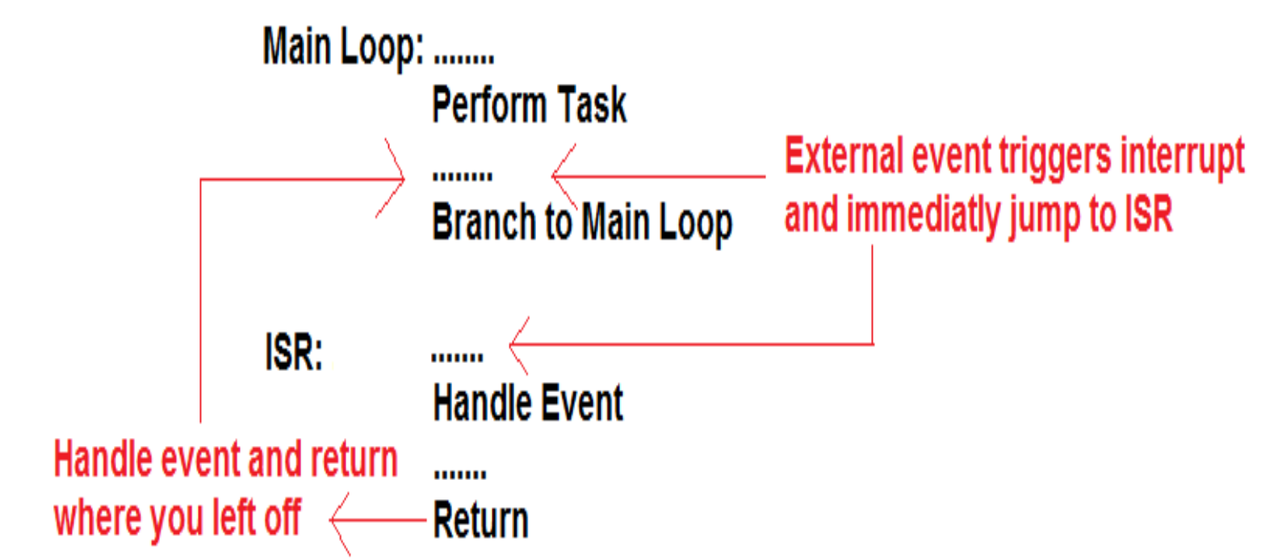

**Figure 1: Proper program flow for an interrupt-driven program**

**SECTION 2**

Thought process for interrupt and debouncing in second half of section 2.

Loop:  
 toggle blue light  
 just jump back to Loop

Interrupt when button is pressed:  
 Start a timer, that’s it

Interrupt when timer ends:  
 check if button is still pressed  
 based on that ^, either increment, or do nothing

**PROGRAM CODE**

**SECTION 1**

MAIN:

; initialize the stack pointer

ldi r16, 0xFF

sts CPU_SPL, r16

ldi r16, 0x3F

sts CPU_SPH, r16

; initialize relevant I/O modules (switches and LEDs)

rcall IO_INIT

; initialize (but do not start) the relevant timer/counter module(s)

rcall TC_INIT

; initialize Interrupts

rcall INTR_INIT

TOGGLE_LOOP:

;Nothing goes here?

;Just keep looping and the timer will count

rjmp TOGGLE_LOOP

DONE:

rjmp DONE

;***********************************************************

; I/O Initializations

;***********************************************************

IO_INIT:

; protect relevant registers

push r16

; initialize the relevant I/O

; LEDs on SLB

ldi r16, 0xFF

sts PORTC_OUT, r16 ; this sets all LEDs

sts PORTC_DIR, r16 ; sets direction as outputs

; recover relevant registers

pop r16

; return from subroutine

ret

;***********************************************************

; Timer Counter initializations

;***********************************************************

TC_INIT:

; protect relevant registers

push r16

; initialize the relevant TC modules

clr r16

sts TCC0_CNT, r16

sts(TCC0_CNT+1), r16

;set TCC0 period register

;TCC0_PER = (fclk/prescalar) * (duration in seconds)

; 2MH/256 0.25

;when you use the reciprocal, you divide by the duration

;assembler can't do decimals

ldi r16, low((F_CPU/CLK_PRE)/FRAME_PER_RECIP_A)

sts TCC0_PER, r16

ldi r16, high((F_CPU/CLK_PRE)/FRAME_PER_RECIP_A) ; 2,000,000/256 /4 = 19536

sts (TCC0_PER + 1), r16

ldi r16, TC_CLKSEL_DIV256_gc ;start the timer

sts TCC0_CTRLA, r16

; recover relevant registers

pop r16

; return from subroutine

ret

;***********************************************************

; Interrupt initializations

;***********************************************************

INTR_INIT:

;protect registers

push r16

ldi r16, TC_OVFINTLVL_LO_gc ; low level. System level

sts TCC0_INTCTRLA, r16

;Turn on low level interrupts

ldi r16, PMIC_LOLVLEN_bm

sts PMIC_CTRL, r16

;enable global interrupt bit

sei

;recover registers

pop r16

ret

;***********************************************************

; Interrupts

;***********************************************************

TOGGLE_ISR:

; first, always preserve the status register

push r16

lds r16, CPU_SREG

push r16

; this is used to toggle every light

ldi r16, 0xFF

sts PORTC_OUTTGL, r16

; clear OVFIF

ldi r16, TC0_OVFIF_bm

sts TCC0_INTFLAGS, r16

; recover the status register

pop r16

sts CPU_SREG, r16

pop r16

reti

**SECTION 2a**

MAIN:

; initialize the stack pointer

ldi r16, 0xFF

sts CPU_SPL, r16

ldi r16, 0x3F

sts CPU_SPH, r16

; initialize relevant I/O modules (switches and LEDs)

rcall IO_INIT

; initialize relevant interrupts

rcall INTR_INIT

;default r20 to have all the lights off. Use this to store our count

ldi r20, 0xFF

OVERALL_LOOP:

;toggle blue here

ldi r16, 0b01000000

sts PORTD_OUTTGL, r16

rjmp OVERALL_LOOP

DONE:

rjmp DONE

;***********************************************************

; I/O Initializations

;***********************************************************

IO_INIT:

; protect relevant registers

push r16

; initialize the relevant I/O

; LEDs on SLB

ldi r16, 0xFF

sts PORTC_OUT, r16 ; this sets all LEDs

sts PORTC_DIR, r16 ; sets direction as outputs

; BLUE_PMW

ldi r16, 0b01000000

sts PORTD_OUTSET, r16 ; set led to off

sts PORTD_DIRSET, r16 ;make it an output

; switch on OOTB SLB

ldi r16, 0b00000100 ; tactical switch 1

sts PORTF_DIRCLR, r16

; recover relevant registers

pop r16

; return from subroutine

ret

;***********************************************************

; Interrupt initializations

;***********************************************************

INTR_INIT:

;protect registers

push r16

;Select pin2 as the interrupt source

ldi r16, 0b00000100

sts PORTF_INT0MASK, r16

;Set as low level interrupt

ldi r16, 1

sts PORTF_INTCTRL, r16

;Only call the interrupt on a falling edge. When the button is pressed

ldi r16, 0b00000010

sts PORTF_PIN2CTRL, r16

;Turn on low level interrupts

ldi r16, PMIC_LOLVLEN_bm

sts PMIC_CTRL, r16

;enable global interrupt bit

sei

;recover registers

pop r16

ret

;***********************************************************

; Interrupts

;***********************************************************

COUNT_ISR:

; first, always preserve the status register

push r16

lds r16, CPU_SREG

push r16

dec r20 ;LEDs are active low, so this is really like adding 1

sts PORTC_OUT, r20

; recover the status register

pop r16

sts CPU_SREG, r16

pop r16

; return from interrupt

reti ;not 'ret'!

**SECTION 2b**

MAIN:

; initialize the stack pointer

ldi r16, 0xFF

sts CPU_SPL, r16

ldi r16, 0x3F

sts CPU_SPH, r16

; initialize relevant I/O modules (switches and LEDs)

rcall IO_INIT

; initialize (but do not start) the relevant timer/counter module(s)

rcall TC_INIT

; initialize relevant interrupts

rcall INTR_INIT

;default r20 to have all the lights off. Use this to store our count

ldi r20, 0xFF

OVERALL_LOOP:

;Just toggle blue light here

ldi r16, 0b01000000

sts PORTD_OUTTGL, r16

rjmp OVERALL_LOOP

DONE:

rjmp DONE

;***********************************************************

; I/O Initializations

;***********************************************************

IO_INIT:

; protect relevant registers

push r16

; initialize the relevant I/O

; LEDs on SLB

ldi r16, 0xFF

sts PORTC_OUT, r16 ; this sets all LEDs

sts PORTC_DIR, r16 ; sets direction as outputs

; BLUE_PMW

ldi r16, 0b01000000

sts PORTD_OUTSET, r16 ; set led to off

sts PORTD_DIRSET, r16 ;make it an output

; switch on OOTB SLB

ldi r16, 0b00000100 ; tactical switch 1

sts PORTF_DIRCLR, r16

; recover relevant registers

pop r16

; return from subroutine

ret

;***********************************************************

; Timer Counter initializations

;***********************************************************

TC_INIT:

; protect relevant registers

push r16

; initialize the relevant TC modules

clr r16

sts TCC0_CNT, r16

sts(TCC0_CNT+1), r16

;set TCC0 period register

;TCC0_PER = (fclk/prescalar) * (duration in seconds)

; 2MH/1 0.01

;when you use the reciprocal, you divide by the duration

;assembler can't do decimals

ldi r16, low((F_CPU/CLK_PRE)/FRAME_PER_RECIP_A)

sts TCC0_PER, r16

ldi r16, high((F_CPU/CLK_PRE)/FRAME_PER_RECIP_A) ; 2,000,000/1 /100 = 20000

sts (TCC0_PER + 1), r16

; recover relevant registers

pop r16

; return from subroutine

ret

;***********************************************************

; Interrupt initializations

;***********************************************************

INTR_INIT:

;protect registers

push r16

;Select pin2 as the interrupt source

ldi r16, 0b00000100

sts PORTF_INT0MASK, r16

;Set as low level interrupt

ldi r16, 1

sts PORTF_INTCTRL, r16

;Only call the interrupt on a falling edge. When the button is pressed

ldi r16, 0b00000010

sts PORTF_PIN2CTRL, r16

;TC interrupt. Low level

ldi r16, TC_OVFINTLVL_LO_gc

sts TCC0_INTCTRLA, r16

;Turn on low level interrupts

ldi r16, PMIC_LOLVLEN_bm

sts PMIC_CTRL, r16

;enable global interrupt bit

sei

;recover registers

pop r16

ret

;***********************************************************

; Interrupts

;***********************************************************

BUTTON_ISR:

;button has been pressed

; first, always preserve the status register

push r16

lds r16, CPU_SREG

push r16

;Debounce switch here. Just start TC

;do the logic of adding and showing LEDs in the TC interrupt

ldi r16, TC_CLKSEL_DIV1_gc

sts TCC0_CTRLA, r16

; recover the status register

pop r16

sts CPU_SREG, r16

pop r16

; return from interrupt

reti ;not 'ret'!

TC_ISR:

;if here, timer has overflowed

; first, always preserve the status register

push r16

lds r16, CPU_SREG

push r16

lds r16, PORTF_IN

sbrs r16, 2 ;skip next instruction if bit = 1 meaning depressed

;if it isn't pressed, debouncing isn't done, skip the decriment

dec r20 ;LEDs are active low, so this is really like adding 1

sts PORTC_OUT, r20

; clear OVFIF

ldi r16, TC0_OVFIF_bm

sts TCC0_INTFLAGS, r16

;Turn off TC

ldi r16, TC_CLKSEL_OFF_gc ;Turn it off

sts TCC0_CTRLA, r16

; recover the status register

pop r16

sts CPU_SREG, r16

pop r16

reti

**APPENDIX**

**SECTION 1**

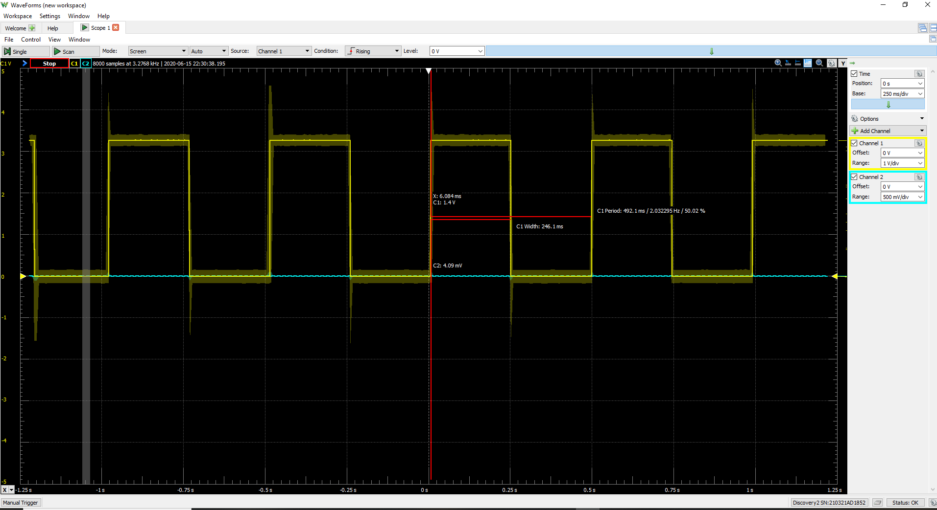

**Figure 2: Output toggling every 250ms from interrupt**

**Code above MAIN**

.include "ATxmega128A1Udef.inc"

.equ F_CPU = 2000000

.equ CLK_PRE = 256

.equ FRAME_PER_A = 1/4 ; 250ms

.equ FRAME_PER_RECIP_A = 4

.ORG 0x0000

rjmp MAIN

.ORG TCC0_OVF_vect

rjmp TOGGLE_ISR

.ORG 0x0100

MAIN:

**SECTION 2a**

**Code above MAIN**

.include "ATxmega128A1Udef.inc"

.ORG 0x0000

rjmp MAIN

.ORG PORTF_INT0_vect

rjmp COUNT_ISR

.ORG 0x0100

MAIN:

**SECTION 2b**

**Code above MAIN**

.include "ATxmega128A1Udef.inc"

.equ F_CPU = 2000000

.equ CLK_PRE = 1

.equ FRAME_PER_A = 1/100 ; 10ms

.equ FRAME_PER_RECIP_A = 100

.ORG 0x0000

rjmp MAIN

.ORG PORTF_INT0_vect

rjmp BUTTON_ISR

.ORG TCC0_OVF_vect

rjmp TC_ISR

.ORG 0x0100

MAIN: